
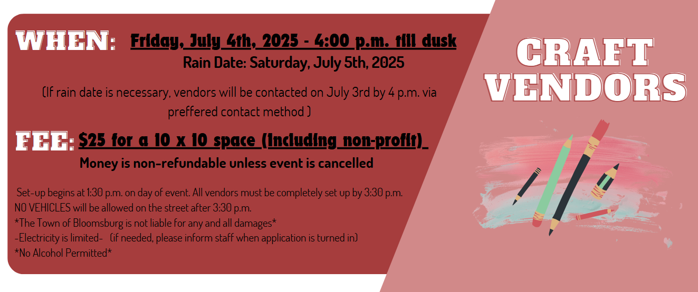
The Town of Bloomsburg Celebration Group is currently accepting applications for vendors. Vendors will be lined on Market Street. The event will culminate with fireworks at dusk.

Business Name: _________________________________________________________________________________________
Contact Person: _________________________________________________________________________________________
Mailing Address: ________________________________________________________________________________________
Preferred Contact (Circle): Phone E-mail

Phone:__________________________________________________________________________________________
E-mail:__________________________________________________________________________________________
Social Media Handle(s): __________________________________________________________________________________
Description of items for sale: _______________________________________________________________________________

Number of spaces requested: _______________

I agree to the above information (Please Sign): _________________________________________
Any questions can be directed to Bloomsburg Town Hall at 570-784-7123 or e-mail to: info@bloomsburgpa.org
Make checks payable to “Town of Bloomsburg”
Please send all payments and applications to:
Town of Bloomsburg, 301 E. 2nd St., Bloomsburg, PA 17815
Cash, Check or Money Order will be accepted
Deadline: June 13, 2025

